Bradley Salus
Peer Adviser Blog
7/17/2020
Fun OC/LA Activities for Both Out-of-Staters and Locals
World-Class Entertainment
Where to start?? It’s hard to compete with Disneyland when it comes to total entertainment. Add that it’s only a 15-minute drive from campus and it makes sense why so many MBKU students choose to get yearly passes there. Alternatively, a cheaper theme park is Knotts Berry Farm that touts some serious roller coasters and thrill rides of its own. It’s also only 15-minutes from campus and is popular around Halloween for its “Knott’s Scary Farm” event. If you’re instead looking for live sports, just head down the 57 Highway into Anaheim to access the sporting arenas for the Los Angeles Angels and Anaheim Mighty Ducks and score game tickets for close to $10 on StubHub (taxes included). Or, if you really want to explore the LA sports scene, head towards LA and find the Dodgers, Lakers/Clippers, Rams/Chargers, and Kings sports arenas that all provide world-class events to attend! You may even spot a celebrity or two in attendance if you look hard enough. Whoops, I forgot to mention all the concert venues and big-name recording artists passing through SoCal each year too…
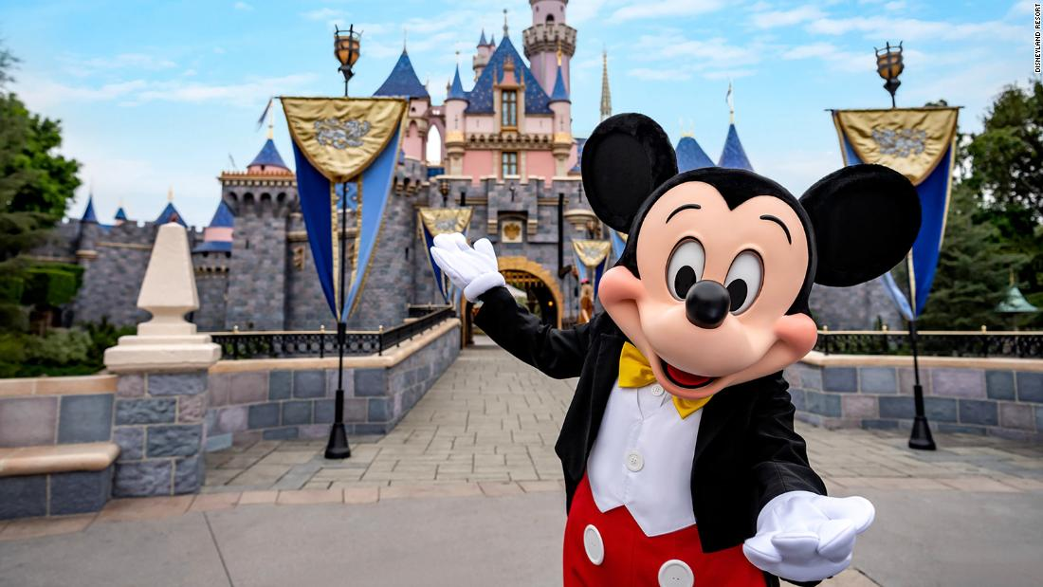
https://cdn.cnn.com/cnnnext/dam/assets/200623124149-01-disneyland-resort-california-super-tease.jpg
Downtown Fullerton / Nightlife / Breweries
Many students choose to head to DTF (Downtown Fullerton) on Friday and Saturday nights to blow off some steam from the school week at the bars and nightclubs. There’s also a wide variety of small shops, eateries and coffee shops that incorporate a little something for everyone not interested in the bar scene. Aside from DTF, the OC area has some of the best breweries in California (and in the nation) just a short drive from campus. Personally, I’d recommend Bottle Logic, Green Cheek, and Bruery Terreux for high-quality brews and trivia events.
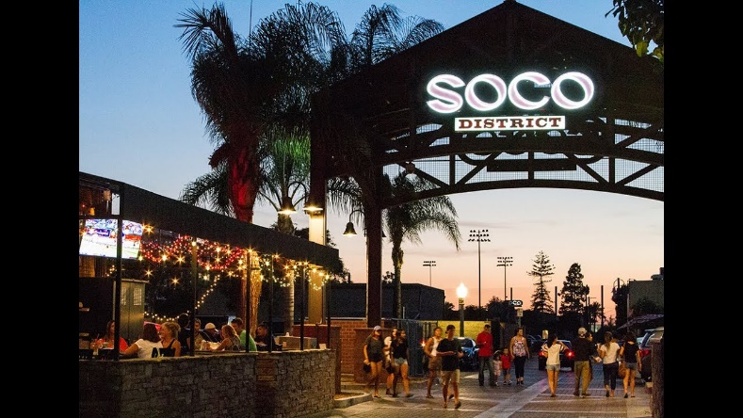
https://i.ytimg.com/vi/KkDO2B3Y9DE/maxresdefault.jpg
Local Outdoor Recreation
With consistently great weather year-round, there’s so much to do in sunny Southern California. Nearby to MBKU is the 11.1-mile Fullerton Loop Trail that’s perfect for walking, running, or biking. Even closer to campus, Craig Regional Park is just up Associated Road or, literally visible from MBKU, the Fullerton Arboretum is just across Yorba Linda Blvd. Both offer a quick break from campus and a nice way to stretch your legs and get some Vitamin D. Other than that, there are parks nearly everywhere with basketball courts (Brea Sports Park) or tennis courts (Carbon Canyon Regional Park) and several public golf courses nearby, too!
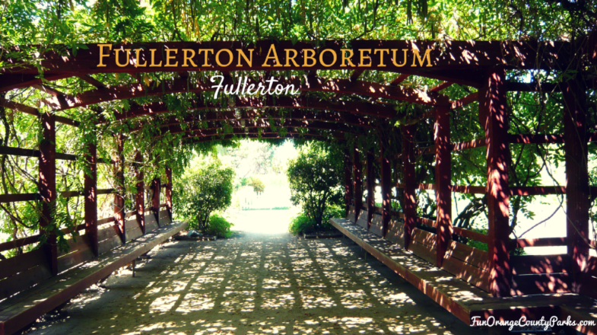
https://i.pinimg.com/originals/ec/d0/14/ecd0143f799fd19c3d8ca1f116f4637f.png
Beaches / PCH
Uh, this is what we all came here for, right?? Hot spot beaches include Huntington, Newport, and Manhattan while Santa Monica Pier and Long Beach both offer a slightly different environment. In these beach towns, you find live events, farmers markets, shopping and dining and, of course, surfing and swimming. If you’ve got some free time, I’d suggest driving the Pacific Coast Highway (Highway 1) into Malibu to see the gorgeous homes and miles of coastline. Truthfully, everyone finds their own favorite beach so stop reading my recommendations and go experience them for yourself!
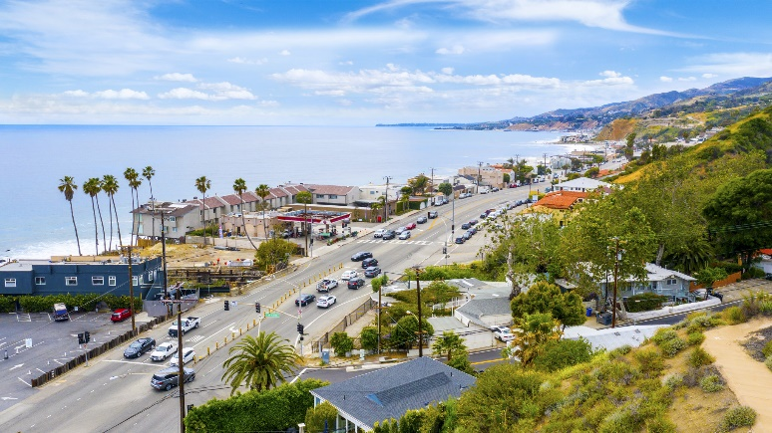
https://images1.loopnet.com/i2/fEUXoKVN4rHKMZQ8aNKqr1FytR3szAi4U_OwLGnY4ug/116/image.jpg
San Diego / Las Vegas
Depending where you’re coming from, this might be your first experience on the west coast. There are some super popular destination cities out here that are easily accessible from LA by car, train, or plane. I’m only going to mention two cities here (but San Francisco probably should’ve been included, too). The first is San Diego. Its only 90 miles south and has a direct train route from the Fullerton Station that passes through some great beach towns. Its known for its incredible weather, vibrant downtown/nightlife, and an awesome coastline and boardwalk. Second, you guessed it, is Las Vegas. It has plenty of cheap flights or is just a short 4-hour drive away. All I can say about Vegas is to check it out sometime with your classmates and be marveled by the lights and nightlife of The Strip!
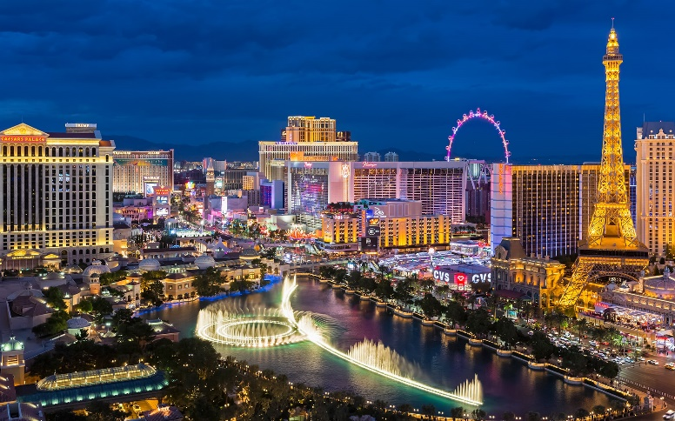
https://www.telegraph.co.uk/content/dam/Travel/Destinations/North%20America/USA/Las%20Vegas/las-vegas-lead-image.jpg

